1. Newtons Laws
2. MC
3. A 90 N force is applied to a 65 kg mass. The mass will accelerate at:

A 0.72 m/s2

B 1.2 m/s2

C 1.4 m/s2

D 5.9 m/s2

1. A skydiver glides to the ground at a steady speed of 7 metres per second. Which statement below best describes what is happening?
   1. The upward force of air resistance acting on the skydiver is smaller than the downward weight force that is acting
   2. The upward force of air resistance that is acting on the skydiver is larger than the size of the downwards weight force
   3. The upward force of air resistance balances the downwards force of gravity acting on the skydiver

D The weight force that acts on the skydiver is larger than the upwards force of air

resistance

1. Which of the following is best explained by Newton’s third law?
   1. Unbelted passengers will be thrown forward when a car stops suddenly.
   2. A gun recoils when a shot is fired.
   3. The acceleration of an object when a force is applied depends on the mass of the object.

D The weight of an object varies from planet to planet.

SA

Classify the following as situations in which forces are balanced or unbalanced.

a. A motor bike accelerating away from traffic lights. (1 mark)

b. A car travelling at a constant 100 kmh-1 straight down a freeway. (1 mark)

A short form of Newton’s First Law is ***inertia***. Explain what inertia is and how it relates to the mass of an object. (2 marks)

ES

Examine the diagram of the water cycle shown. Identify the processes occurring at 1, 2, 3, 4 and 5 in that order.

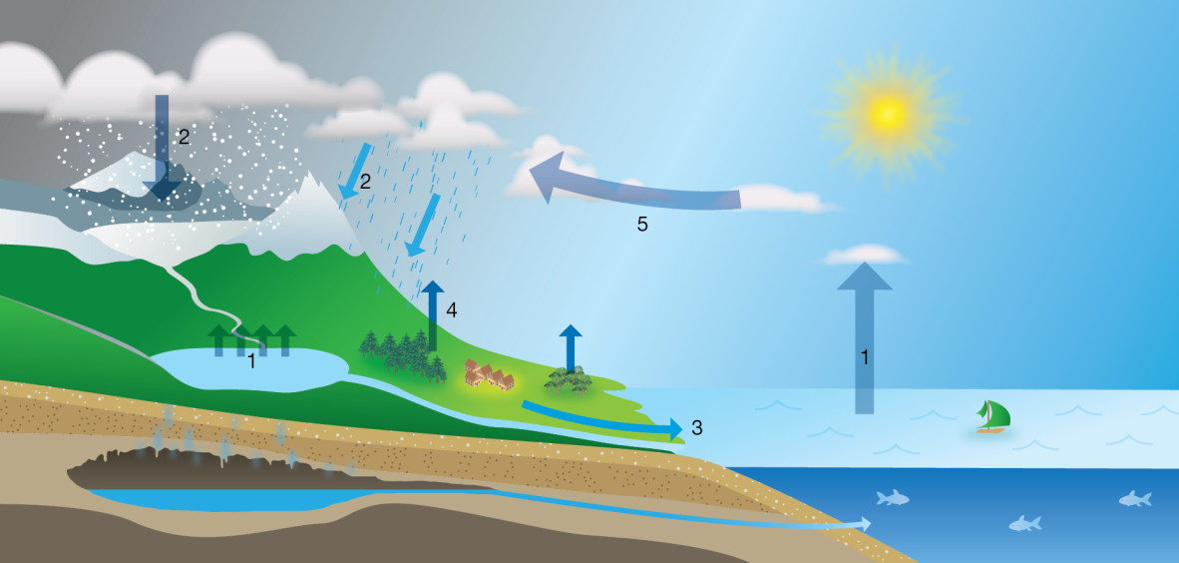

A evaporation; precipitation; run-off; condensation; transpiration

B precipitation; evaporation; transpiration; condensation; run-off

C evaporation; precipitation; run-off; transpiration; condensation

D transpiration; condensation; run-off; precipitation; evaporation

1. Identify the best description of what global warming is.

A periods of global warming occur between periods of glaciation

B greenhouse gases in the atmosphere cause global warming

C global warming began after the Industrial Revolution

D during periods of global warming sea levels fall exposing more land

1. Describesustainable ecosystems.

A ecosystems that provide many different resources for humans

B stable ecosystems that have survived unchanged for thousands of years

C diverse ecosystems that provide for the needs of the organisms that live there

D ecosystems that survive without any input from humans

1. Which statement does NOT describe greenhouse gases or the effect they have?

A Nitrogen and oxygen are greenhouse gases that absorb the short-wave radiation coming into Earth’s atmosphere from the Sun.

B Water vapour and carbon dioxide in the atmosphere have no effect on the short-wave radiation coming into Earth’s atmosphere from the Sun.

C Greenhouse gases trap heat close to the surface of the Earth keeping it warmer than it would be without those gases.

D Carbon dioxide and methane absorb long-wave radiation and re-emit it in all directions

including back to Earth.

Identify the list that contains some of the main causes of ocean currents.

A temperature; variations in salinity; revolution of the Earth around the Sun

B variations in salinity; rotation of the Earth; position of continents

C wind; position of continents; gravitational pull of the Sun and Moon

D gravitational pull of the Sun and Moon; temperature; rotation of the Earth

1. What is an UNLIKELY effect of global warming?

A Plants found on mountain tops will extend their range towards the lower slopes and valleys.

B Winters become shorter in many places so that the growing season is increased.

C Melting ice causes sea levels to rise inundating low lying areas.

D Animals found in warm seas will extend their range away from the equator and towards

the poles.

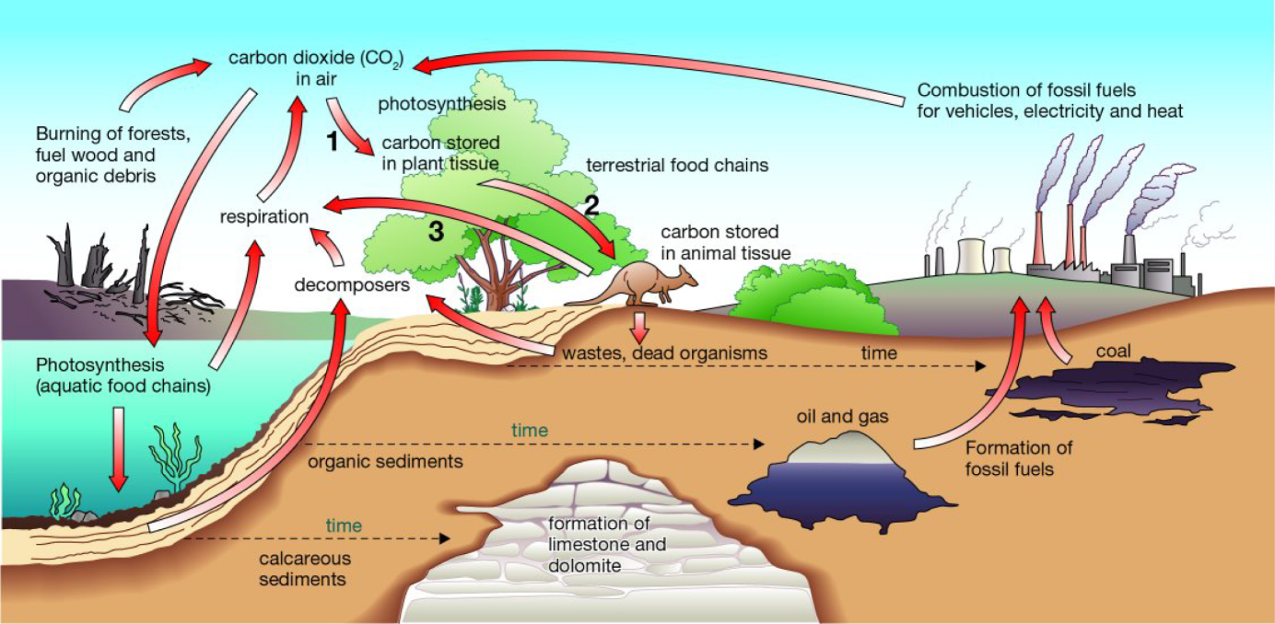

Figure 1

Part of the carbon cycle

The diagram represents part of the carbon cycle. (6 marks)

**a Construct** a statement for each of the numbered arrows, describing what happens at that step.

**b Explain** why the recycling of materials is important to the continued functioning of ecosystems.

**a 1** Plant uses carbon dioxide (CO2) in photosynthesis.

**2** Plants become food for herbivores; carbon compounds present in plants become incorporated into animals’ tissues.

**3** Cellular respiration produces CO2 as a by-product, which is released back into the atmosphere.

**b** Recycling of materials ensures that substances become available again for use by plants and animals in the ecosystem. If materials were not recycled but were locked up in the dead remains of plants and animals, fewer and fewer resources would be available for new organisms. Eventually life would cease to exist.

1. **Explain** how each of the following can be used as evidence of climate past change.

**a** ice cores

**b** sedimentary rocks

**c** glaciers (3marks)

**a** On some glaciers and ice sheets, sufficient snow falls each year to form recognisable annual layers. Scientists take cores from the ice and then analyse its physical and chemical properties. The analysis provides information about temperatures and the composition of the air from hundreds of thousands of years in the past.

**b** The worldwide distribution of sedimentary rocks and the types of fossils found in them are indicators of changes in sea level in the past. For example, sedimentary rocks in the dry area of central Australia contain fossils of sea creatures.

**c** Glaciers advance when the climate cools and retreat when the climate warms.

As glaciers move, they grind against the rocks on the sides and floor of the valley through which they flow. The rocks on the side of the valley are deeply scored by broken rocks being dragged along the sides and base of the glacier. When the glacier retreats, the scoring of the rocks becomes visible. Scoring in the rock and the presence of moraines indicates where there have been glaciers in the past.

Chemistry

1. Which product in the following chemical reaction is dissolved in solution?

CaCO3(s) + 2HCl(aq) → CaCl2(aq) + CO2(g) + H2O(l)

A HCl

B CaCl2

C CO2

D H2O

1. Which unbalanced formula equation best represents the following word equation?
2. iron(III) oxide + carbon monoxide → iron + carbon dioxide

A Fe2O3 + CO → Fe + CO2

B FeO + CO → Fe + CO2

C Fe2O3 + CO2 → Fe + CO

D FeO + CO2 → Fe + CO

1. Which of the following equations is balanced?

A C2H6 + O2 → CO2 + H2O

B C2H6 + O2 → 2CO2 + 3H2O

C C2H6 + 7O2 → 2CO2 + 3H2O

D 2C2H6 + 7O2 → 4CO2 + 6H2O

1. Which of the following chemical reactions is a combination reaction?

A 2H2O(l) → 2H2(g) + O2(g)

B 2H2(g) + O2(g) → 2H2O(l)

C H2O2 → H2 + O2(g)

D H2O + Na → NaOH + H2

1. Which is the best term to describe the following reaction?
2. CaCO3(s) → CaO(s) + CO2(g)

A combination reaction

B metal displacement reaction

C precipitation reaction

D decomposition reaction

1. When solutions of sodium chloride (NaCl) and silver nitrate (AgNO3) are mixed, solid silver chloride (AgCl) forms. Which ions remain dissolved in the solution?

A Na+ and Cl−

B Ag+ and Cl−

C Na+ and 

D Ag+ and 

1. Explain why crushing solid reactants helps to increase the rate of reaction.

A It exposes more of the solid reactant to the other reactants so there can be more reactions occurring at any one time.

B It weakens the chemical bonds in the solid so that it is easier for the reaction to occur.

C It helps the solid to dissolve.

D All answers are correct.

1. Explain why adding a catalyst to a reaction increases the rate of reaction.

A The catalyst can provide a pathway for the chemical reaction that requires less energy.

B The catalyst can help the reactant molecules to come together and react.

C The catalyst can force reactants into the correct arrangement so that they react.

D All answers are correct.

1. An experiment was conducted as shown in the diagram below.
2. 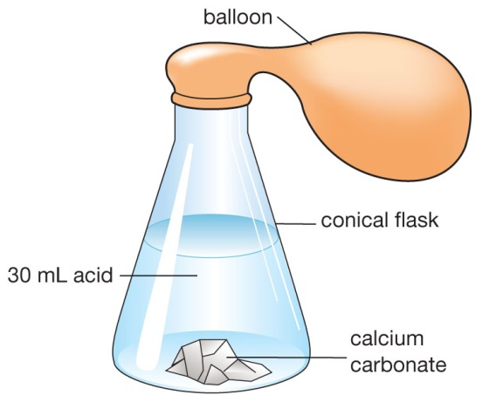
3. CaCO3(s) was added to HCl(aq). The flask, contents and balloon were weighed before and after the reaction. The products of the reaction are water (H2O), carbon dioxide gas (CO2) and a solution of calcium chloride (CaCl2). (5 marks)

A Write a balanced equation (including states) for the reaction occurring in the flask.

B Would you expect the mass after the reaction to be greater than, less than or equal to the mass before reaction? Justify your choice.

* 1. CaCO3(s) + 2HCl(aq) → CaCl2(aq) + CO2(g)+ H2O
  2. The mass should be the same before and after the reaction. The Law of Conservation of Mass states that mass is neither created nor destroyed during a chemical reaction.  
      or  
     The mass would be slightly less because some gas might have been lost when the balloon was being attached to the flask, as the reaction was beginning.

1. The production of iron metal from iron ore uses a complex series of reactions that all take place within a blast furnace. The reactions are:

A 2C + O2 → 2CO

B Fe2O3 + CO → Fe + CO2

C CaCO3 → CaO + CO2

D SiO2 + 2CaO → Ca2SiO4

1. **Identify** which of these reactions are: (3 marks)

a combination reactions

b decomposition reactions

c combustion reactions

a reactions A and D

b reaction C only

c reactions A and B

1. List five ways in which the rate of a reaction may be increased. (5 marks)
2. higher temperature
3. more concentrated reactants
4. agitation (stirring)
5. larger surface area
6. use of a catalyst

Give the name or chemical formula for the following compounds: (6 marks)

1. Magnesium hydroxide
2. CO
3. Ammonium sulfate
4. NH3
5. Aluminium oxide
6. Sulfuric acid
7. Magnesium hydroxide ***Mg(OH)2***
8. CO ***carbon dioxide***
9. Ammonium sulfate ***(NH4)2SO4***
10. NH3 ***ammonia***
11. Aluminium oxide ***Al2O3***
12. Sulfuric acid ***H2SO4***

Balance the following equations: (4 marks)

1. _____ Fe + _____ AgNO3 🡪 _____ Fe(NO3)2 + _____ Ag
2. _____ S8 + _____O2 🡪 _____SO2
3. _____V2O5 + _____ CaS 🡪 _____CaO + _____V2S5

d) _____ AgI + _____ Fe2(CO3)3 🡪 _____ FeI3 + _____ Ag2CO3

1. _____ Fe + __**2**___ AgNO3 🡪 _____ Fe(NO3)2 + __**2**___ Ag
2. _____ S8 + __**8**___O2 🡪 __**8**___SO2
3. _____V2O5 + __**5**___ CaS 🡪 ___**5**__CaO + _____V2S5

__**6**___ AgI + _____ Fe2(CO3)3 🡪 __**2**___ FeI3 + __**3**___ Ag2CO3

For each of the following chemical reactions: (5 marks)

* Determine whether a precipitate will form;
* If a precipitate forms, write the chemical formula for this solid. (1 mark)
* Write the balanced ionic equation for those reactions which will produce a precipitate. (1 mark)

(If no precipitate forms write **no reaction**)

1. lead (ll) nitrate and sodium iodide

***precipitate is PbI2 (1 mark)***

***Pb2+ + 2I-🡪 PbI2 (1 mark)***

1. sodium hydroxide and magnesium nitrate

***precipitate is Mg(OH)2 (1 mark)***

***Mg2+ + 2OH-🡪 Mg(OH)2 (1 mark)***

1. ammonium nitrate and potassium phosphate

***no reaction (1 mark)***